**Default 22.aspx page**

<%@ Page Language="C#" AutoEventWireup="true" CodeFile="Default22.aspx.cs" Inherits="Default22" %>

<!DOCTYPE html>

<html xmlns="http://www.w3.org/1999/xhtml">

<head runat="server">

<title></title>

<script type="text/javascript">

// Javascript function to open the new window

function OpenNewWindow()

{

var Name = document.getElementById('txtName').value;

var Email = document.getElementById('txtEmail').value;

window.open('WebForm2.aspx?Name=' + Name + '&Email=' + Email, '_blank', 'toolbar=no, location=no, resizable=yes, width=500px, height=500px', true);

}

</script>

</head>

<body>

<form id="form1" runat="server">

<div>

Name:

<asp:TextBox ID="TextBox1" runat="server"></asp:TextBox>

<br />

password:

<asp:TextBox ID="TextBox2" runat="server"></asp:TextBox>

<br />

<asp:Button ID="Button1" runat="server" Text="submit" OnClick="Button1_Click" />

</div>

</form>

</body>

</html>

**SCREENSHOT**

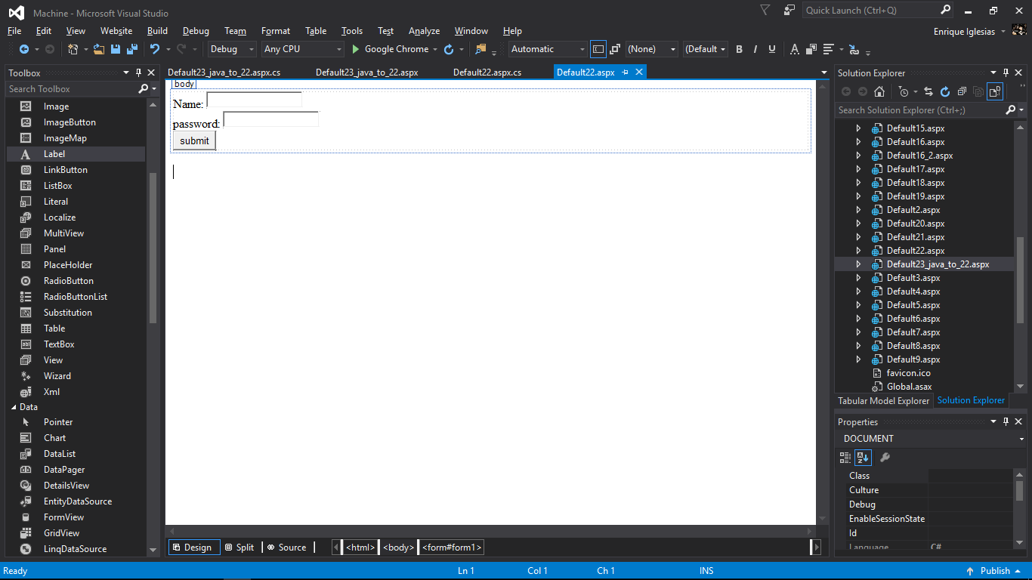

**Default 22.aspx.CS page**

using System;

using System.Collections.Generic;

using System.Linq;

using System.Web;

using System.Web.UI;

using System.Web.UI.WebControls;

public partial class Default22 : System.Web.UI.Page

{

protected void Page_Load(object sender, EventArgs e)

{

}

protected void Button1_Click(object sender, EventArgs e)

{

string a = TextBox1.Text;

string b = TextBox2.Text;

Session["Id"] = a;

Session["Id2"] = b;

**string strJavascript = "<script type='text/javascript'>window.open('Default23_java_to_22.aspx', '_blank', 'location=no'); </script>";**

Response.Write(strJavascript);

}

}

**Default 23.aspx page**

<%@ Page Language="C#" AutoEventWireup="true" CodeFile="Default23_java_to_22.aspx.cs" Inherits="Default23_java_to_22" %>

<!DOCTYPE html>

<html xmlns="http://www.w3.org/1999/xhtml">

<head runat="server">

<title></title>

</head>

<body>

<form id="form1" runat="server">

<div>

name:

<asp:Label ID="Label1" runat="server"></asp:Label>

<br />

password:

<asp:Label ID="Label2" runat="server"></asp:Label>

</div>

</form>

</body>

</html>

**SCREENSHOT**

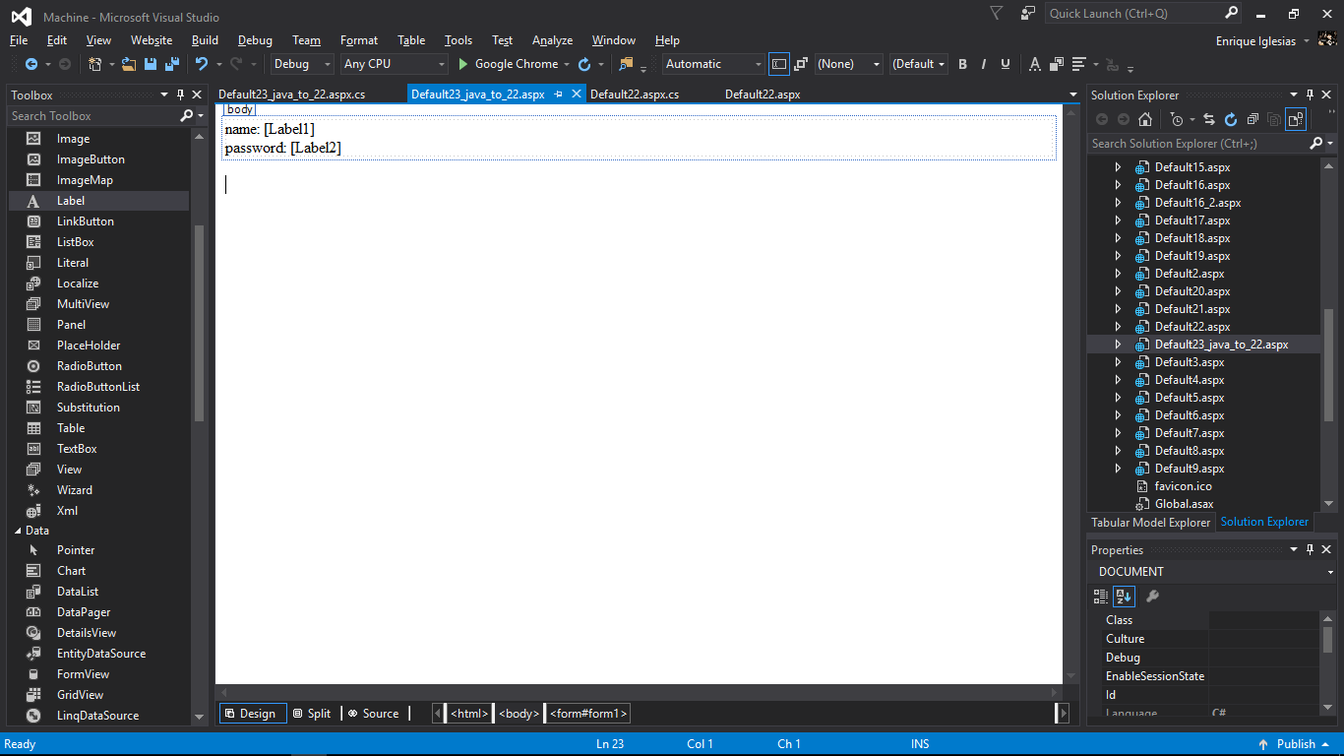

**Default 23.aspx.CS page**

using System;

using System.Collections.Generic;

using System.Linq;

using System.Web;

using System.Web.UI;

using System.Web.UI.WebControls;

public partial class Default23_java_to_22 : System.Web.UI.Page

{

protected void Page_Load(object sender, EventArgs e)

{

Label1.Text = Session["Id"].ToString();

Label2.Text = Session["Id2"].ToString();

}

}

|  |  |
| --- | --- |
| Parameter Name | Description |
| URL (Optional) | The URL of the page to open. If URL is not specified, a new window with about:blank is opened. |
| Name (Optional) | Specifies the target attribute or the name of the window.   * name - The name of the window * _blank - Opens in a new window. Default, if nothing is specified. * _self - Opens in the same page * _parent - Loaded into the parent frame * _top - URL replaces any framesets that may be loaded |
| Features (optional) | A comma-separated list of items.   * resizable = yes|no or 0|1 * scrollbars = yes|no or 0|1 * toolbar = yes|no or 0|1 * location = yes|no or 0|1(Specifies whether to display the Navigation Bar. The default is yes) * status = yes|no or 0|1 * menubar = yes|no or 0|1 * left = yes|no or pixels * top = yes|no or pixels * width = yes|no or pixels * height = yes|no or pixels |
| Replace(Optional) | A boolean parameter that specifies whether the url creates a new entry or replaces the current entry in the window's history list. This parameter only takes effect if the url is loaded into the same window.   * **true** - url replaces the current document in the history list. * **false** - url creates a new entry in the history list. |

**OUTPUT**

